**Terminal Practice:**

1. Open Terminal

After download the Git Bash, click right in the screen to open the terminal

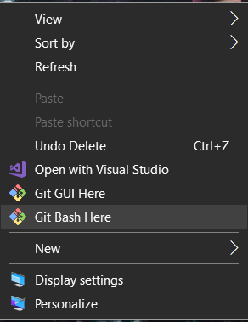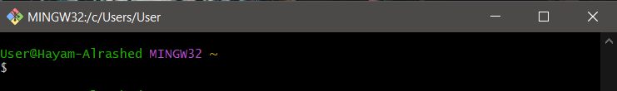

1. Navigate to your Desktop

Using cd to relocated

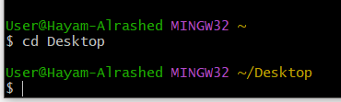

1. Create a new directory, call it 'test'
2. Make files called index.html, style.css, commands.txt inside the test directory
3. Make a copy of index.html and call it index_2.html
4. Navigate back to you desktop and make another directory, call it destination
5. Move the index_2.html file to the 'destination' directory
6. In the 'test' directory, remove the 'styles.css' file
7. Now, check and see what files are in the 'test' and 'destination' directories
8. Remove/delete the 'destination' directory
9. Spend 10 minutes researching some other terminal commands and keep them in mind for the future!
10. Write the commands you used to do the above and save them in commands.txt. Then upload it below.
11. Display the contents of commands.txt in the terminal